 | 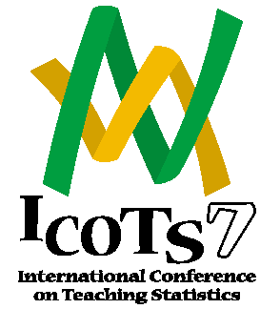 | 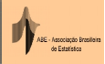
Working Cooperatively in Statistics Education

Salvador (Bahia), Brazil, July 2-7, 2006

http://www.maths.otago.ac.nz/icots7

Call for Contributed Papers and Posters

The International Association for Statistical Education (IASE) and the International Statistical Institute (ISI) are organizing the Seventh International Conference on Teaching Statistics (ICOTS-7) which will be hosted by the Brazilian Statistical Association (ABE) in Salvador (Bahia), Brazil, July 2-7, 2006.

Most of the 54 Invited Paper Sessions (arranged into 9 different Topics) are complete. In addition 4 Special Interest Group Meetings (3 of them in both Portuguese and Spanish) have been arranged for those interested in discussing a particular theme.

Call for contributed papers and posters

Contributed papers and posters dealing with any aspect of statistics education are welcome.

Contributed paper will be arranged in a variety of Sessions, taking into account the proposals received. An optional refereeing process will be arranged for those wishing their papers to be refereed.

Those interested in submitting a contributed paper should contact either Joachim Engel (Engel_Joachim@ph-ludwigsburg.de) or Alan McLean (alan.mclean@buseco.monash.edu.au) before September 1, 2005.

Those interested in submitting a poster should contact Celi Lopes (celilopes@uol.com.br) before February, 1, 2006.

Detailed guidelines for authors, deadlines and other information are available at the ICOTS web site at http://www.maths.otago.ac.nz/icots7

More information can be obtained from Carmen Batanero, batanero@ugr.es

